**Insight Stream: Navigate the News Landscape**

**Ideation Phase**

**Empathize & Discover**

|  |  |
| --- | --- |
| Date | 11/03/2025 |
| Team ID | ID-149960 |
| Project Name | Insight Stream: Navigate the News Landscape |
| Maximum Marks | 4 Marks |

**Empathy Map Canvas:**

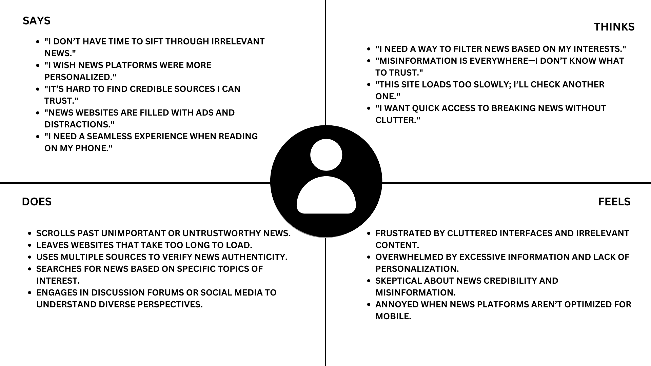

#### ****SAYS****

* "I don’t have time to sift through irrelevant news."
* "I wish news platforms were more personalized."
* "It’s hard to find credible sources I can trust."
* "News websites are filled with ads and distractions."

#### ****THINKS****

* "I need a way to filter news based on my interests."
* "Misinformation is everywhere—I don’t know what to trust."
* "This site loads too slowly; I’ll check another one."

#### ****DOES****

* Scrolls past unimportant or untrustworthy news.
* Leaves websites that take too long to load.
* Uses multiple sources to verify news authenticity.
* Searches for news based on specific topics of interest.

#### ****FEELS****

* Frustrated by cluttered interfaces and irrelevant content.
* Overwhelmed by excessive information and lack of personalization.
* Sceptical about news credibility and misinformation.